

4
e-Project
Report

Supervisor : Vo Duc Thien
Curriculum: ACCP i7.1
Semester: 2 – DISM.
Batch Code: 1007E
Team Leader: Le Ngoc Thanh
Members : Tran Le Quoc Hung
Quach Vinh Quang
Tran Cam Thanh





This is to certify that
Mr. Le Ngoc Thanh
has successfully designed and
developed
Leave Management System
Submitted by:

Le Ngoc Thanh
Date of Issue: 15/03/2012
Authorized Signature: ___________

This is to certify that
Mr. Tran Le Quoc Hung
has successfully designed and
developed
Leave Management System

Submitted by:

Tran Le Quoc Hung
Date of Issue: 15/03/2012
Authorized Signature: ___________

This is to certify that
Mr. Quach Vinh Quang
has successfully designed and
developed
Leave Management System

Submitted by:

Quach Vinh Quang
Date of Issue: 15/03/2012
Authorized Signature: ___________

This is to certify that
Mr. Tran Cam Thanh
has successfully designed and
developed
Leave Management System

Submitted by:

Tran Cam Thanh
Date of Issue: 15/03/2012
Authorized Signature: ___________

1. Problem Statement

Our client is a manufacturer of the telecom products, like mobiles, landlines, wireless phones, etc . with different features like speaker phone, in - built phone book, call tracking system, SMS facility, voice recording features, answering m/c facility, etc .. Several telecom companies like BSNL, etc . Actually the clients of this manufacturer used to visit or ask for the sales person to visit their premises in order to select the type of the product, and place a request for some quantity of the products as per their requirement. Also they receive the order from some customers who want to have a parallel connection for their existing telecom connection with some features like speaker phone, answering m/c incorporated, etc.... Also due to the increase in the vendors of various telecom providers, the increase in demand for the telecom product manufacturers is increased.
Due to some arrears in the delivery of the product, or due to some failures
Table of Contents

1. Problem Statement………………………………………………….6
2. Use-Case Diagram ………………………………………………….7
3. Use-Case Specification …………………………………………….11
4. Flow Chart………………………………………………………….29
5. Database Design……………………………………………………58
6. Site Map…………………………………………………………….10
7.Interface System…………………………………………………….11
8. Task Sheet…………………………………………………………..22

1. Problem Statement

Every Organization has many managers, who are responsible for all the activities in the organization. These managers manage different aspects of the organizational management issues, such as manufacturing, production, Marketing, etc; one such essential management issue is “Industraial Manpower Resource Organiser” (IMPRO).

As years progressed, the approach of the management changed towards the human capital. Now Hierarchical Organization is part of every organization, and has its own identity and importance. In this scenario, the bigger organizations need to put lot of effort in the management of human Resources, as they are underlying capital asset to the organization. In doing so, along with times, the Organization Information changed from its basic operations to more strategic approach.
Some of the features are.

- Finding ground level employee performance by the topmast manager.
- Maintenance of profile details of the employees, and retrievals as and when required.
- Overall & detailed view of the organization hierarchy, which is very much essential in making effective decisions.
- Judging the potentiality of the employees.
- Maintenance of the data when the organization has many branches spread over wide geographical area.
- Accessing one branch information from another branch.
- Future planning issues based on the current HR information.
- Employees success planning.
- Vacancy situations and their priority /effect on the organizations performance.
- Employee motivational & conflict resolving issues.
As the whole project is based on the logical perspective of an ideal organization’s Human Capital Management structure, the physical implementation has no fixed rules, thus implementing the concept little difficult.

2. Use-Case Diagram

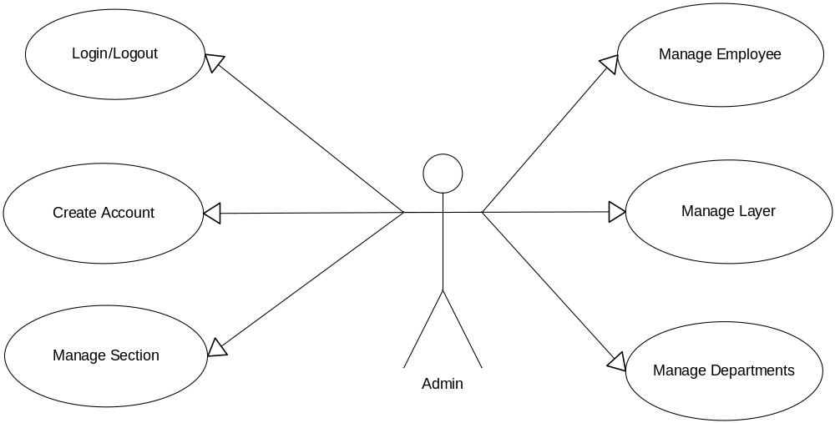
Picture 1 – Actor Admin.

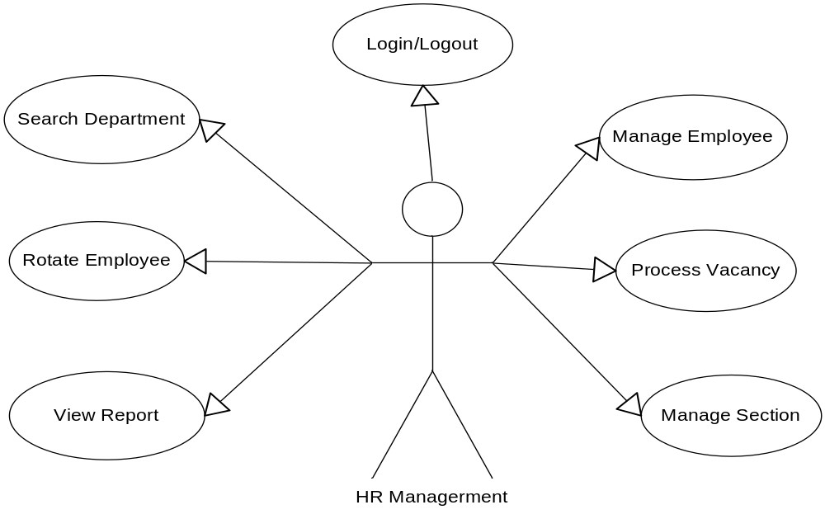
Picture 2 – Actor HR Managerment.

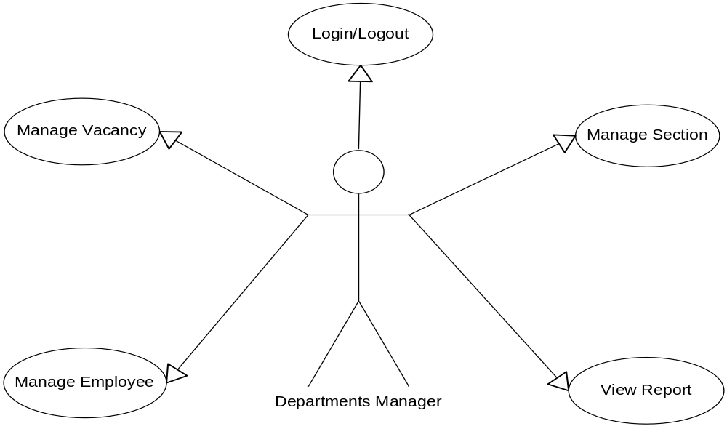
Picture 3 – Actor Departments Manager.

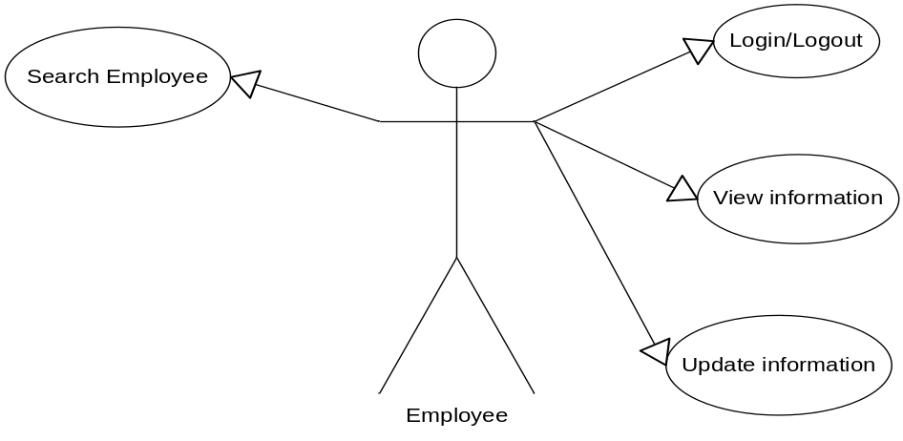
Picture 4 – Actor Employee.

3. Use-Case Specification
3.1 List of Actors

No. | Actor | Comment
1 | Admin | Manage all
2 | HR Managerment | Manage Employee , Manage Section,
3 | Departments | Manage Employee , Vacancy , Section and View report
4 | Employee | Update information and Search Employee

3.2 List of Use-Case

No. | Use-Case | Comment
1 | Login | Users logged into the system
2 | Logout | Users exit the system
3 | Create Account | Add an account in account list
4 | Update Account | Update details of account
5 | Delete Account | Delete an account in account list
6 | Add Section | Add a section in section list
7 | Update Section | Update details of section
8 | Delete Section | Delete a Section in Section list
9 | Search Section | Find section based on section’s name
10 | Add Employee | Add an employee in employee list
11 | Update Employee | Update details of employee
12 | Delete Employee | Delete an employee in employee list
13 | Search Employee | Find employee based on employee’s name or full name
14 | Add layer | Add a layer in layer list
15 | Update Layer | Update detail of layer
16 | Delete Layer | Delete a layer in layer list
17 | Search Layer | Find layer based on layer’s id
18 | Add Departments | Add an department in department list
19 | Update Departments | Update detail of department
20 | Delete Departments | Delete a department in department list
21 | Search Department | Find department based on department’s name
22 | Rotate Employee | Rotate employee between departments
23 | Process Vacancy | Add employee in departments
24 | View report | Details of report
25 | Add Vacancy | Add a vacancy in vacancy list
26 | Update Vacancy | Update detail of vacancy
27 | Delete Vacancy | Delete a vacancy in vacancy list
28 | Search Vacancy | Find vacancy based on vacancy’s number
29 | View Information | Details of information
30 | Update Information | Update information of accounts
31 | History of Employee | Details history of employees

3.3 Description
3.3.1 Login

Use Case | Login
Summary : | Function “Login” allows user login to system with corresponding powers
Major Events: | Step 1 : When user start application “Form Login” will be displayed  Step 2 : User enter their username and password  Step 3 : Press button “Login” program will check username and password in database.  Step 4 : If exist program will display a confirmation message “Login Successful”  Else program will display a confirmation message “Login Failed”  Step 5 : User press button “Exit” to exit this form
Other Events:

3.3.2 Logout

Use Case | Logout
Summary : | Function “Logout” help user logout the program
Major Event : | Step 1 : When user want to signout click "Logout" on the program interface  Step 2 : Program will display a confirmation message “Do you want to sign out?”  Step 3 : If click “Yes” user will exit program and disconnect with database  If click “No” user will turn back application interface
Other Events :

3.3.3 Create Account

Use Case | Create Account
Summary : | Function “Create Account” help user create an account
Major Events : | Step1 : Click on tab “Account List”  Step 2 : Press button “ Create Account”  Step 3 : Form “ Create Account” will be displayed. User can insert information of account  Step 4 : Press button “Add” program will display a confirmation message “Do you want to create an account?”  Step 5 : Click “Yes” the account will be added into the database and displayed on application  Or click “No” account won’t be added
Other Events :

3.3.4 Update Account

Use Case | Update Account
Summary : | Function “Update Account” help user update information of account
Major Events : | Step 1 : Click on tab “Account list”  Step 2 : Select a section wants to update then click button “Update Account”  Step 3 : “Form Update Account” will be displayed on screen , user edits information of account and then press button “Update”  Step 4 : : Program will display a confirmation message “Do you want to update this account?”  If click “OK” account will be updated into database and displayed in account list  If click “No” account won’t be updated
Other Events :

3.3.5 Delete Account

Use Case | Delete Account
Summary : | Function “ Delete Account” help user delete an account from account list
Major Events : | Step 1: In tab “Account list” user can view Account list  Step 2 :User can choose an account wants to delete and press button “Delete”  Step 3 :Program will display a confirmation message “Do you want to delete this account?”  Step 4 : If click “Yes” account will be deleted into database and don’t display in account list  If click “ No” Undelete account

3.3.6 Add Section

Use Case | Add Section
Summary : | Function “Add Section” help user add a section to section list
Major Events : | Step 1 : Click on tab “Section list”  Step 2 : Press button “Add Section”  Step 3 : “Form Add Section” will be displayed. User enter information of section and press button “Add”  Step 4 :Program will display a confirmation message “Do you want to add section?”  Step 5 : If click “OK” section will be added into database and displayed in section list  If click “No” section won’t be added
Other Events :

3.3.7 Update Section

Use Case | Update Section
Summary : | Function “Update Section” help user update information of section
Major Events : | Step 1 : Click on tab “Section list”  Step 2 : Select a section wants to update then click button “Update Section”  Step 3 : “Form Update Section” will be displayed on screen , user edits information of section and then press button “Update”  Step 4 : : Program will display a confirmation message “Do you want to update this section?”  If click “OK” section will be updated into database and displayed in section list  If click “No” section won’t be updated
Other Events :

3.3.8 Delete Section

Use Case | Delete Section
Summary : | Function “ Delete Section” help user delete a section from section list
Major Events : | Step 1: In tab “Section list” user can view section list  Step 2 :User can choose a section wants to delete and press button “Delete”  Step 3 :Program will display a confirmation message “Do you want to delete this section?”  Step 4 : If click “Yes” section will be deleted into database and don’t display in section list  If click “ No” Undelete section
Other Events :

3.3.9 Search Section

Use Case | Search Section
Summary : | Find section in section list
Major Events : | Step 1 : Click on tab “Section list”  Step 2 : Enter name of section  Step 3 : Program will check this information in database  Step 4 : If exist program will display this section  Else Program will display a confirmation message “No section in section list”.
Other Events :

3.3.10 Add Employee

Use Case | Add Employee
Summary : | Function “Add Employee” help user add an employee to employee list
Major Events : | Step 1 : Click on tab “Employee list”  Step 2 : Press button “Add Employee”  Step 3 : “Form Add Employee” will be displayed. User enter information of employee and press button “Add”  Step 4 :Program will display a confirmation message “Do you want to add employee?”  Step 5 : If click “OK”emlpoyee will be added into database and displayed in employee list  If click “No” employee won’t be added
Other Events :

3.3.11 Update Employee

Use Case | Update Employee
Summary : | Function “Update Employee” help user update information of employee
Major Events : | Step 1 : Click on tab “Employee list”  Step 2 : Select an employee wants to update then click button “Update Employee”  Step 3 : “Form Update Employee” will be displayed on screen , user edits information of employee and then press button “Update”  Step 4 : : Program will display a confirmation message “Do you want to update this employee?”  If click “OK” employee will be updated into database and displayed in employee list  If click “No” employee won’t be updated
Other Events :

3.3.12 Delete Employee

Use Case | Delete Employee
Summary : | Function “ Delete Employee” help user delete an employee from employee list
Major Events : | Step 1: In tab “Employee list” user can view employee list  Step 2 :User can chose an employee wants to delete and press button “Delete”  Step 3 :Program will display a confirmation message “Do you want to delete this employee?”  Step 4 : If click “Yes” employee will be deleted into database and don’t display in employee list  If click “ No” Undelete employee
Other Events :

3.3.13 Search Employee

Use Case | Search Employee
Summary : | Find employee in employee list
Major Events : | Step 1 : Click on tab “Employee list”  Step 2 : Enter name of employee  Step 3 : Program will check this information in database  Step 4 : If exist program will display this employee  Else Program will display a confirmation message “No employee in employee list”.
Other Events :

3.3.14 Add Layer

Use Case | Add Layer
Summary : | Function “Add Layer” help user add a layer to layer list
Major Events : | Step 1 : Click on tab “Layer list”  Step 2 : Press button “Add Layer”  Step 3 : “Form Add Layer” will be displayed. User enter information of layer and press button “Add”  Step 4 :Program will display a confirmation message “Do you want to add layer?”  Step 5 : If click “OK” layer will be added into database and displayed in layer list  If click “No” layer won’t be added
Other Events :

3.3.15 Update Layer

Use Case | Update Layer
Summary : | Function “Update Layer” help user update information of layer
Major Events : | Step 1 : Click on tab “Layer list”  Step 2 : Select a layer wants to update then click button “Update Layer”  Step 3 : “Form Update layer” will be displayed on screen , user edits information of layer and then press button “Update”  Step 4 : : Program will display a confirmation message “Do you want to update this layer?”  If click “OK” layer will be updated into database and displayed in layer list  If click “No” layer won’t be updated
Other Events :

3.3.16 Delete Layer

Use Case | Delete Layer
Summary : | Function “ Delete Layer” help user delete a layer from layer list
Major Events : | Step 1: In tab “Layer list” user can view a layer list  Step 2 :User can choose a layer wants to delete and press button “Delete”  Step 3 :Program will display a confirmation message “Do you want to delete this layer?”  Step 4 : If click “Yes” layer will be deleted into database and don’t display in layer list  If click “ No” Undelete layer
Other Events :

3.3.17 Search Layer

Use Case | Search Layer
Summary : | Find layer in layer list
Major Events : | Step 1 : Click on tab “Layer list”  Step 2 : Enter id of layer  Step 3 : Program will check this information in database  Step 4 : If exist program will display this layer  Else Program will display a confirmation message “No layer in layer list”.
Other Events :

3.3.18 Add Department

Use Case | Add Department
Summary : | Function “Add Department” help user add a department to department list
Major Events : | Step 1 : Click on tab “Department list”  Step 2 : Press button “Add Department”  Step 3 : “Form Add Department” will be displayed. User enter information of department and press button “Add”  Step 4 :Program will display a confirmation message “Do you want to add department?”  Step 5 : If click “OK” department will be added into database and displayed in department list  If click “No” department won’t be added
Other Events :

3.3.19 Update Department

Use Case | Update Department
Summary : | Function “Update Department” help user update information of department
Major Events : | Step 1 : Click on tab “Department list”  Step 2 : Select a department wants to update then click button “Update Department”  Step 3 : “Form Update Department” will be displayed on screen , user edits information of department and then press button “Update”  Step 4 : : Program will display a confirmation message “Do you want to update this department?”  If click “OK” department will be updated into database and displayed in department list  If click “No” department won’t be updated
Other Events :

3.3.20 Delete Department

Use Case | Delete Department
Summary : | Function “ Delete Department” help user delete a department from department list
Major Events : | Step 1: In tab “Department list” user can view department list  Step 2 :User can choose a department wants to delete and press button “Delete”  Step 3 :Program will display a confirmation message “Do you want to delete this department?”  Step 4 : If click “Yes” department will be deleted into database and don’t display in department list  If click “ No” Undelete department
Other Events :

3.3.21 Search Department

Use Case | Search Department
Summary : | Find department in department list
Major Events : | Step 1 : Click on tab “Department list”  Step 2 : Enter name of department  Step 3 : Program will check this information in database  Step 4 : If exist program will display this department  Else Program will display a confirmation message “No department in department list”.
Other Events :

3.3.22 Rotate Employee

Use Case | Rotate Employee
Summary : | Function “Rotate Employee” help user can rotate employee between departments
Major Events : | Step 1 : Click on tab “Employee list”  Step 2 : Select an employee wants to rotate then click button “Rotate Employee”  Step 3 : “Form Rotate Employee” will be displayed on screen , user edit employee’s deparment and then press button “Rotate”  Step 4 : : Program will display a confirmation message “Do you want to rotate this employee?”  If click “OK” employee will be updated into database and displayed in employee list  If click “No” employee won’t be rotated
Other Events :

3.3.23 Process vacancy

Use Case | Process vacancy
Summary : | Function “Process Vacancy” help user can appoint employee in departments
Major Events : | Step 1 : Click on tab “Vacancy list”  Step 2 : Select a vacancy wants to process then click button “Process Vacancy”  Step 3 : “Form Process Vacancy” will be displayed on screen , user appoint employee in deparment and then press button “Process”  Step 4 : : Program will display a confirmation message “Do you want to process this vacancy?”  If click “OK” vacancy will be updated into database and displayed in vacancy list  If click “No” vacancy won’t be processed
Other Events :

3.3.24 View Report

Use Case | View Report
Summary : | Show all action of user when they’re logging in program
Major Events : | Step 1 : Click on tab “View Report”  Step 2 : “Form View Report” will be displayed on screen.  Step 3: User can print report by press button “Print”
Other Events :

3.3.25 Add Vacancy

Use Case | Add Vacancy
Summary : | Function “Add Vacancy” help user add a vacancy to vacancy list
Major Events : | Step 1 : Click on tab “Vacancy list”  Step 2 : Press button “Add Vacancy”  Step 3 : “Form Add Vacancy” will be displayed. User enter information of vacancy and press button “Add”  Step 4 :Program will display a confirmation message “Do you want to add vacancy?”  Step 5 : If click “OK” vacancy will be added into database and displayed in vacancy list  If click “No” vacancy won’t be added
Other Events :

3.3.26 Update Vacancy

Use Case | Update Vacancy
Summary : | Function “Update Vacancy” help user update information of vacancy
Major Events : | Step 1 : Click on tab “Vacancy list”  Step 2 : Select a vacancy wants to update then click button “Update Vacancy”  Step 3 : “Form Update Vacancy” will be displayed on screen , user edits information of vacancy and then press button “Update”  Step 4 : : Program will display a confirmation message “Do you want to update this vacancy?”  If click “OK” vacancy will be updated into database and displayed in vacancy list  If click “No” vacancy won’t be updated
Other Events :

3.3.27 Delete Vacancy

Use Case | Delete Vacancy
Summary : | Function “ Delete Vacancy” help user delete a vacancy from vacancy list
Major Events : | Step 1: In tab “Vacancy list” user can view vacancy list  Step 2 :User can choose a vacancy wants to delete and press button “Delete”  Step 3 :Program will display a confirmation message “Do you want to delete this vacancy?”  Step 4 : If click “Yes” vacancy will be deleted into database and don’t display in vacancy list  If click “ No” Undelete vacancy
Other Events :

3.3.28 Search Vacancy

Use Case | Search Vacancy
Summary : | Find vacancy in vacancy list
Major Events : | Step 1 : Click on tab “Vacancy list”  Step 2 : Enter id of vacancy  Step 3 : Program will check this information in database  Step 4 : If exist program will display this vacancy  Else Program will display a confirmation message “No vacancy in vacancy list”.
Other Events :

3.3.29 Search User Login Information

Use Case | View Information
Summary : | Find personal information of user (employee)
Major Events : | Step 1 : Click on tab “Information”  Step 2 : “Form Information” will be displayed on screen, this form will show personal information of user is logging  Step 3: User can view personal information of another user by enter user’s name and then press button “Search Information”
Other Events :

3.3.30 Update User Login Information

Use Case | Update Information
Summary : | Function “Update Information” help user (employee) update only their personal information
Major Events : | Step 1 : Click on tab “Information”  Step 2 : “Form Information” will be displayed on screen, user can edit only their personal information (address, no.phone, fax, email ) and then press button “Update Information”  Step 3 : : Program will display a confirmation message “Do you want to update your information?”  If click “OK” user’s information will be updated into database and displayed in employee list  If click “No” user’s personal information won’t be update
Other Events :

3.3.31 History of Employee

Use Case | History of Employee
Summary : | Show history of employee
Major Events : | Step 1 : Click on tab “Employee list”  Step 2 : User can choose employee wants to view his/her history and press button “History”  Step 3 : Program will show his/her history from joining until now  Step 4: User can print his/her history by press button “Print”
Other Events :

4. Flow Chart

4.1.Login

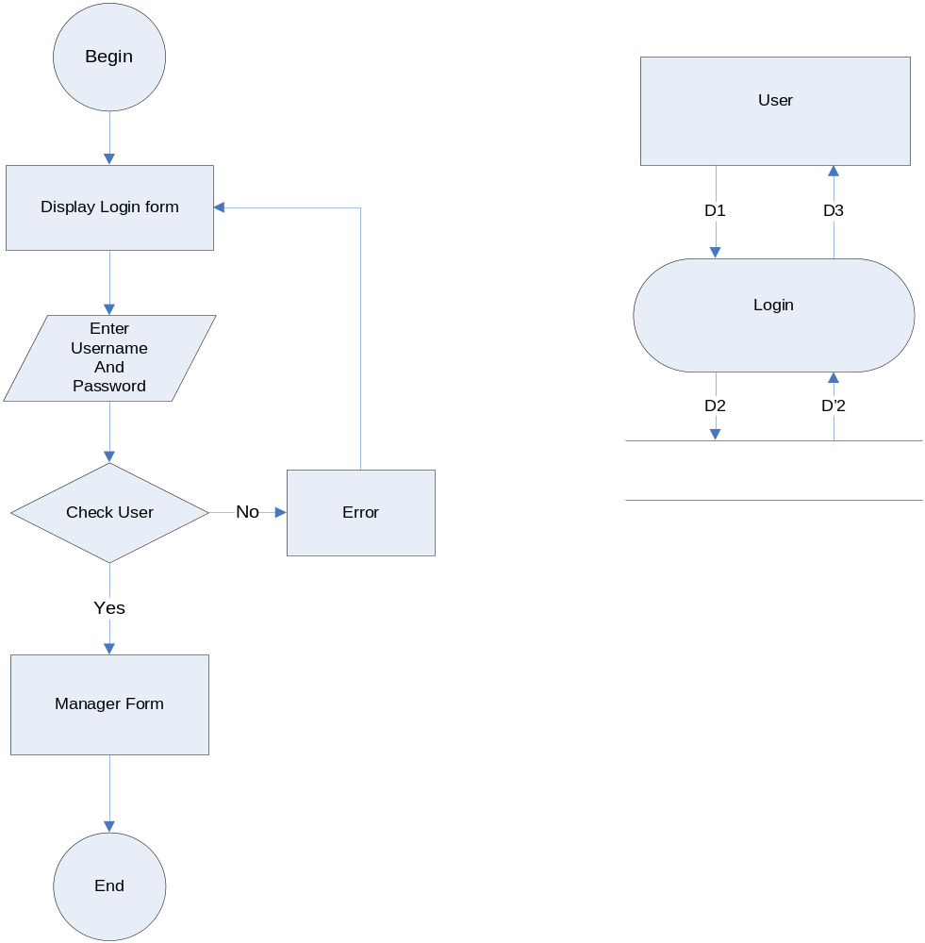
4.2.Logout

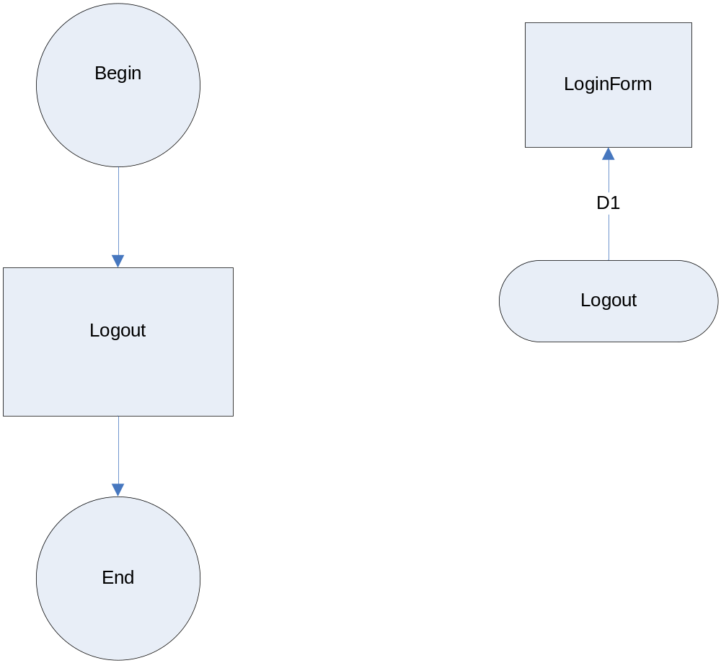

4.3.Create Account

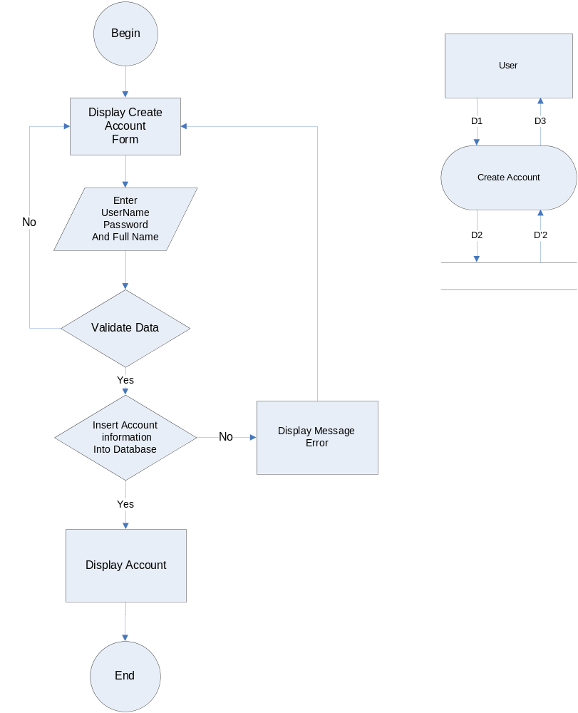
4.4.Update Account
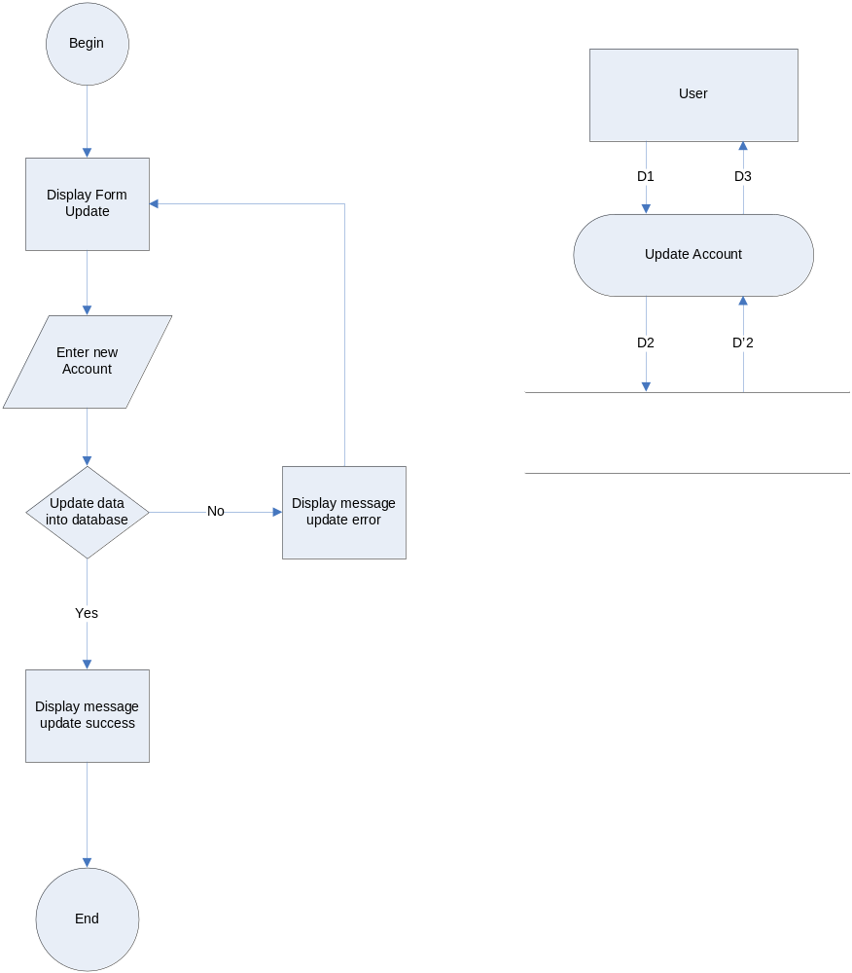
4.5. Delete Account
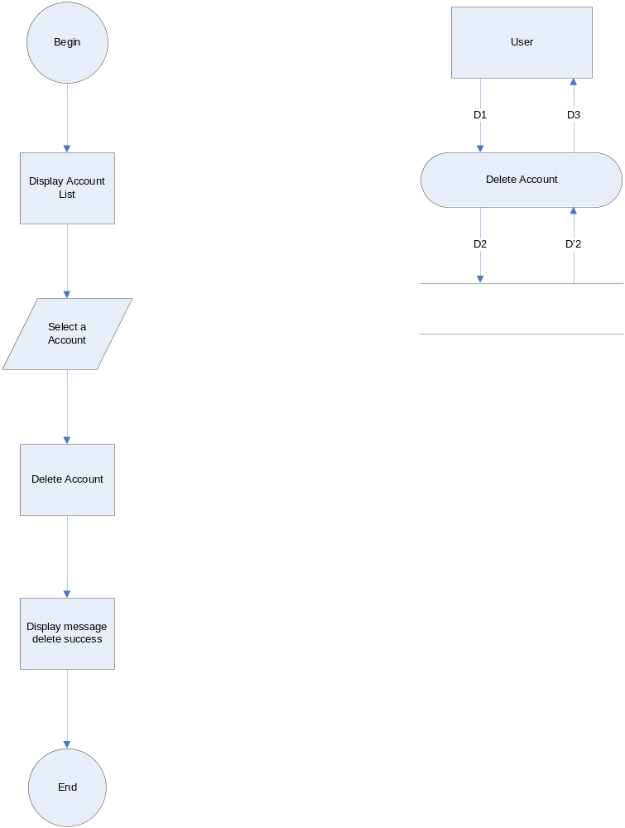
4.6. Add Section
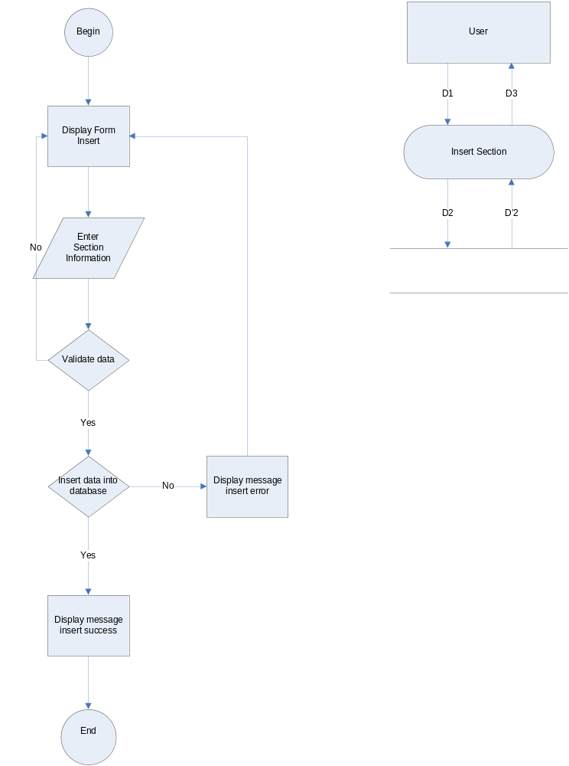
4.7. Update Section
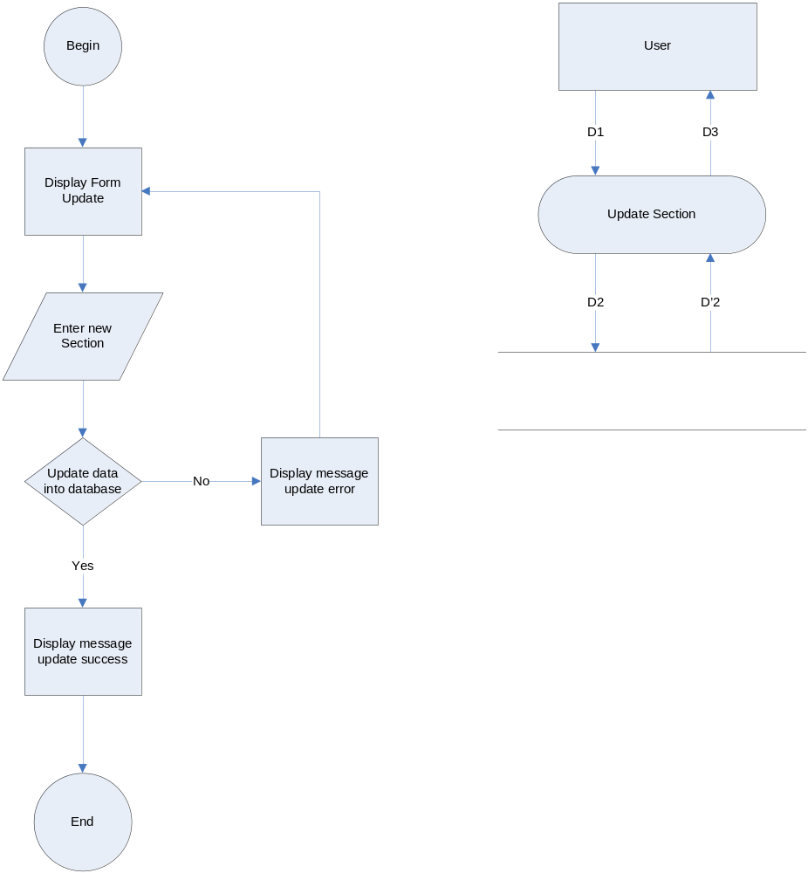
4.8. Delete Section
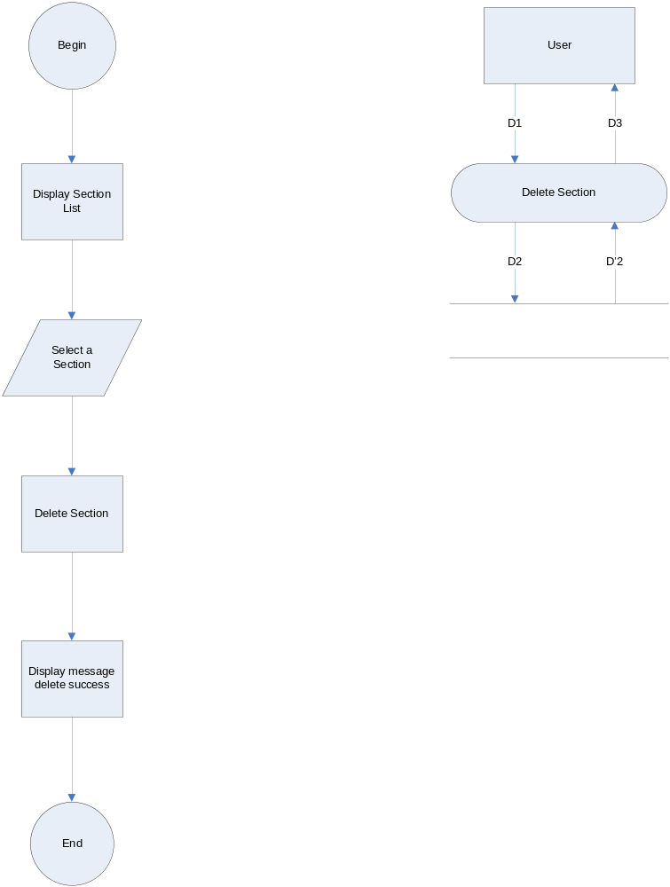
4.9. Search Section
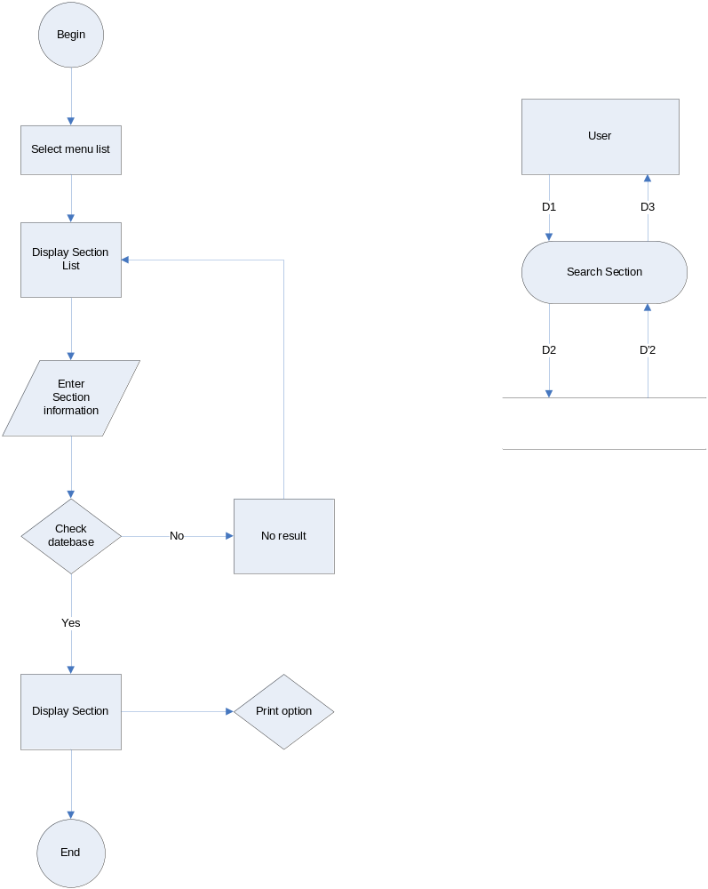
4.10. Add Employee
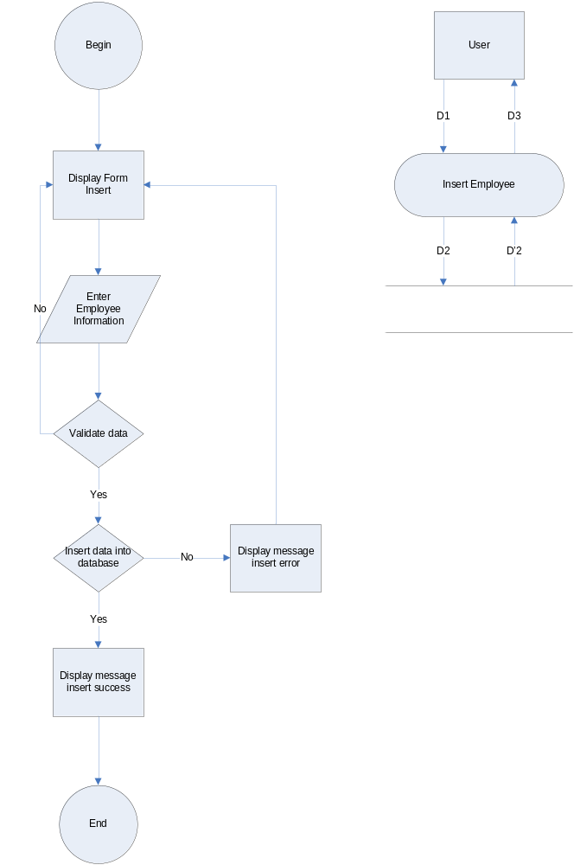
4.11. Update Employee
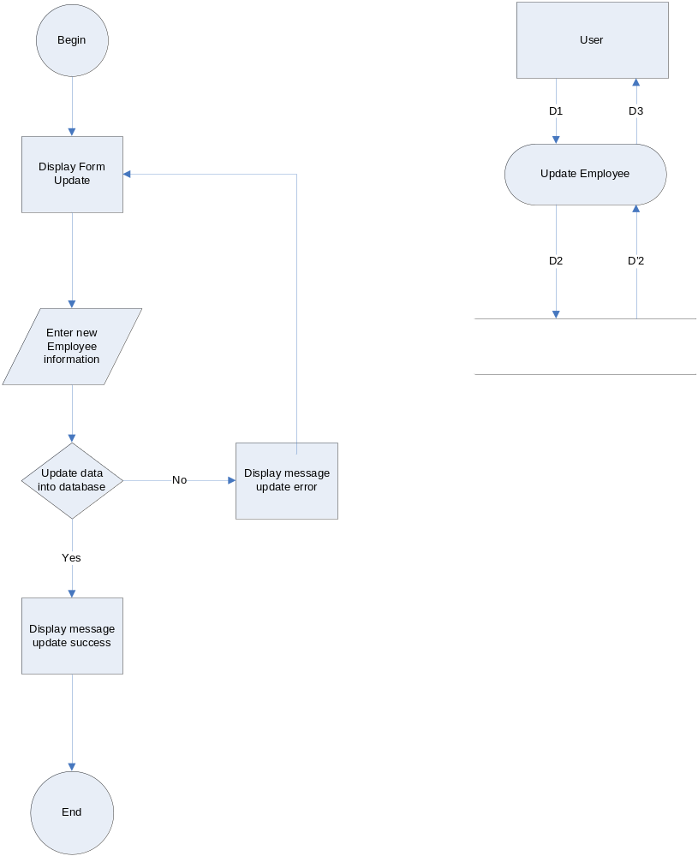
4.12.Delete Employee
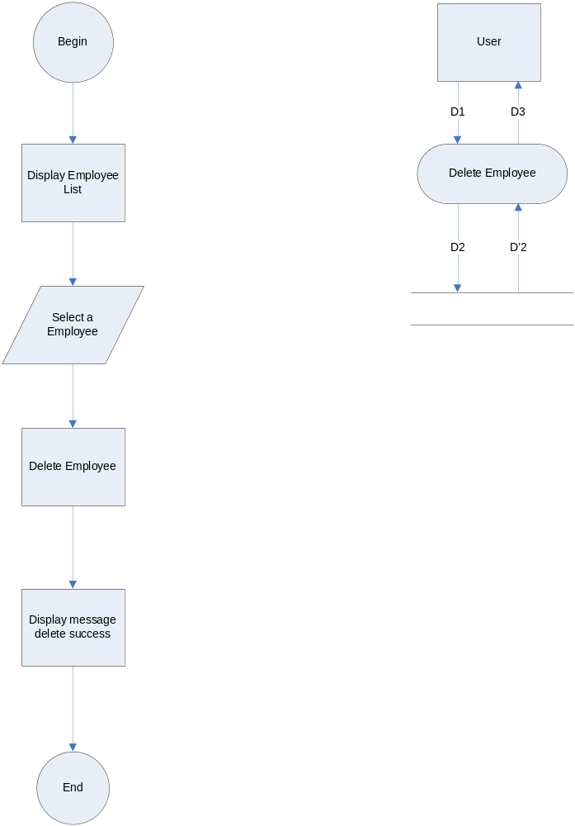
4.13.Search Employee
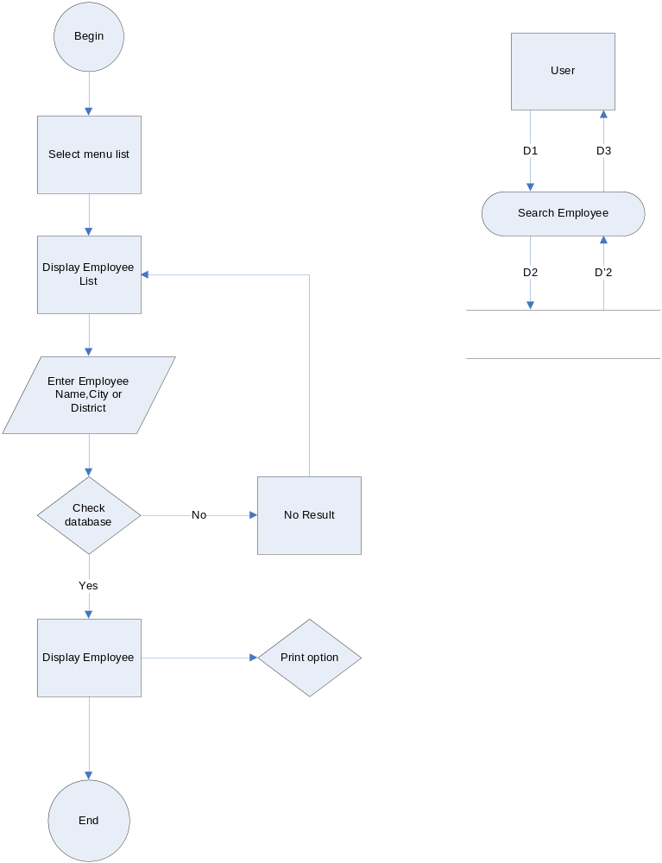
4.14 Add Layer
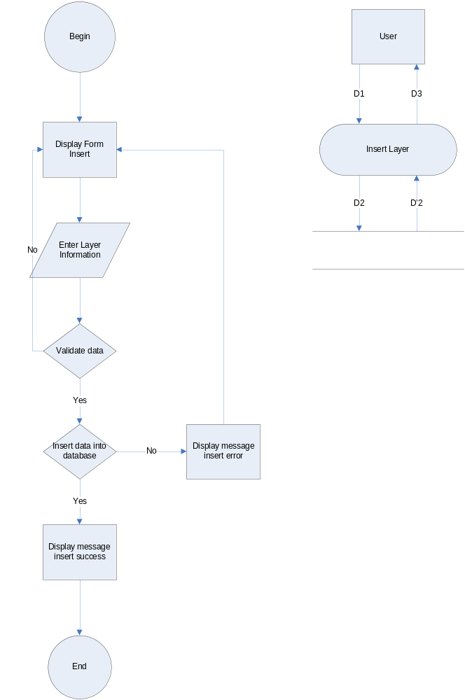
4.15.Update Layer
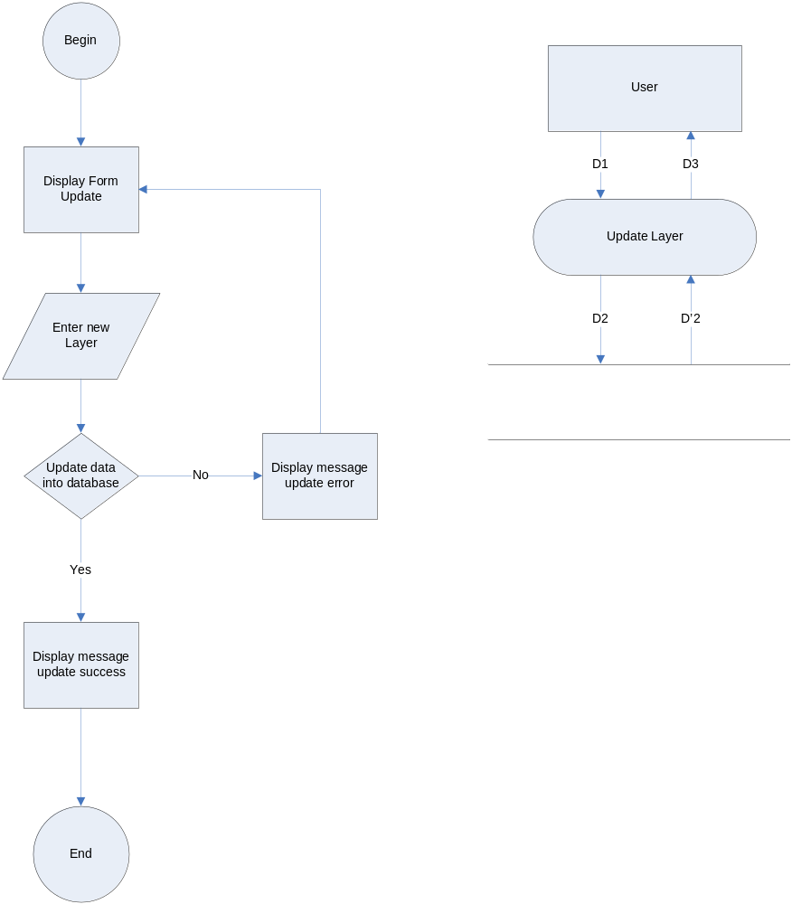
4.16.Delete Layer
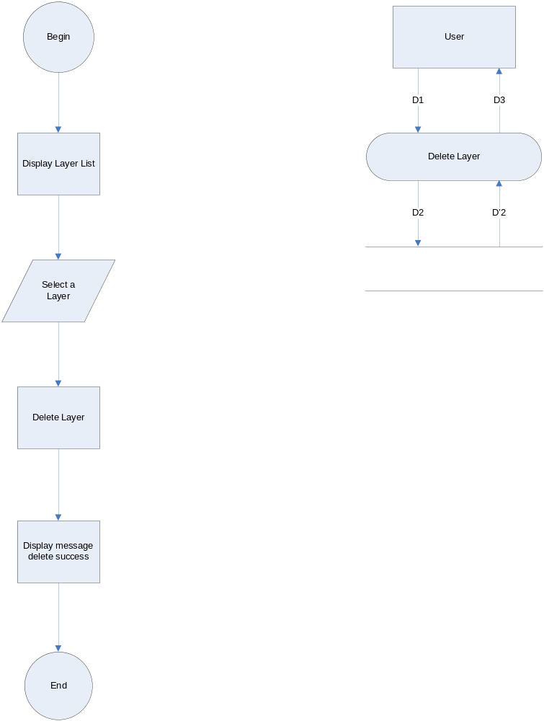
4.17.Search Layer
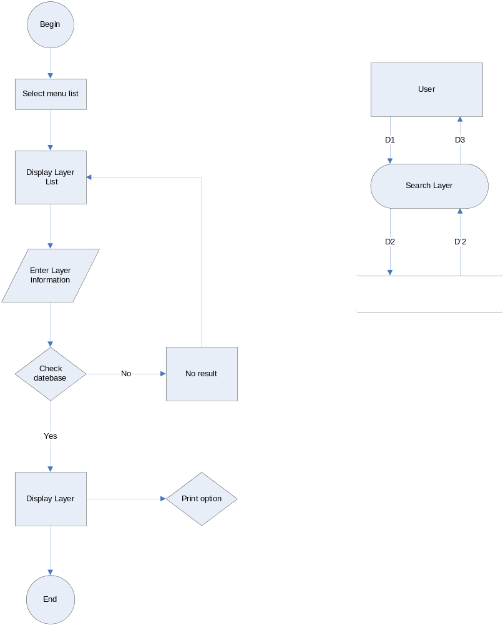
4.18.Add Departments
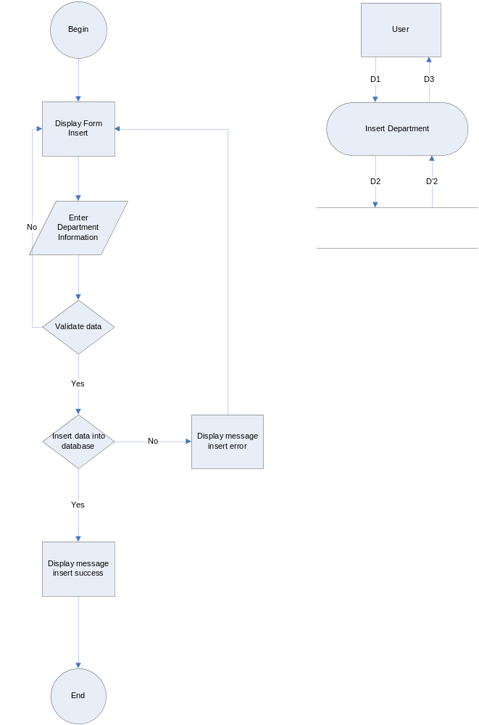
4.19.Update Departments
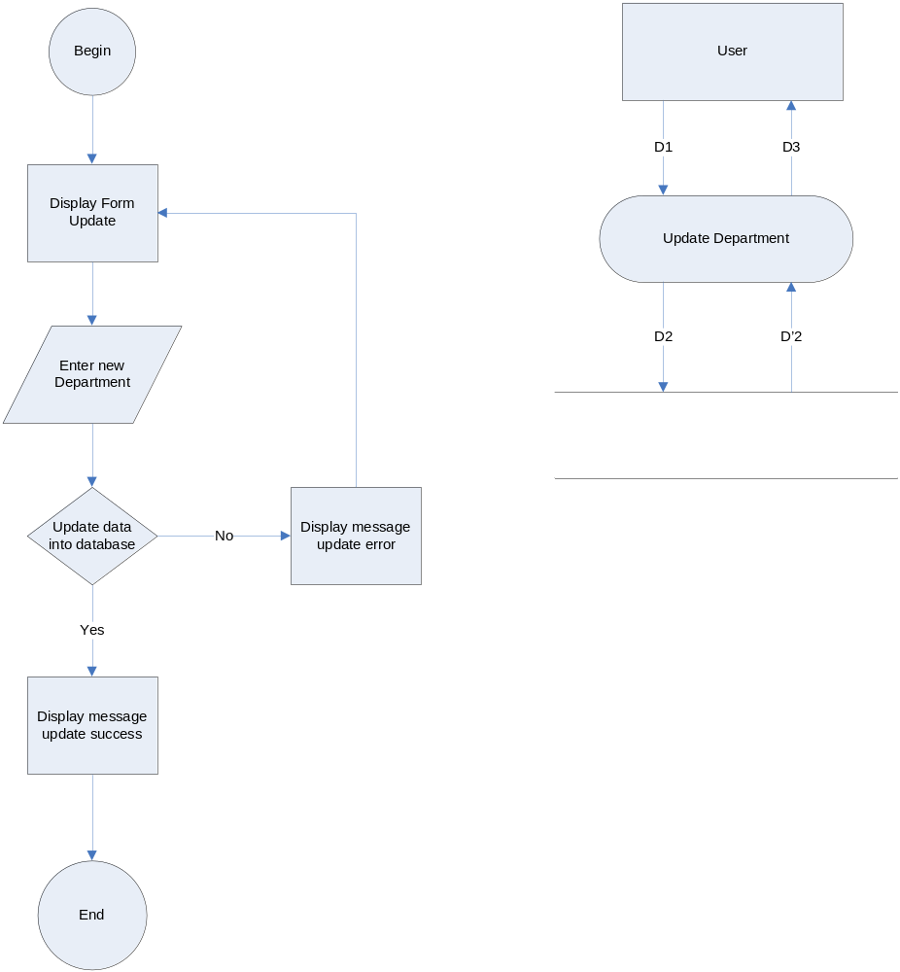
4.20.Delete Departments
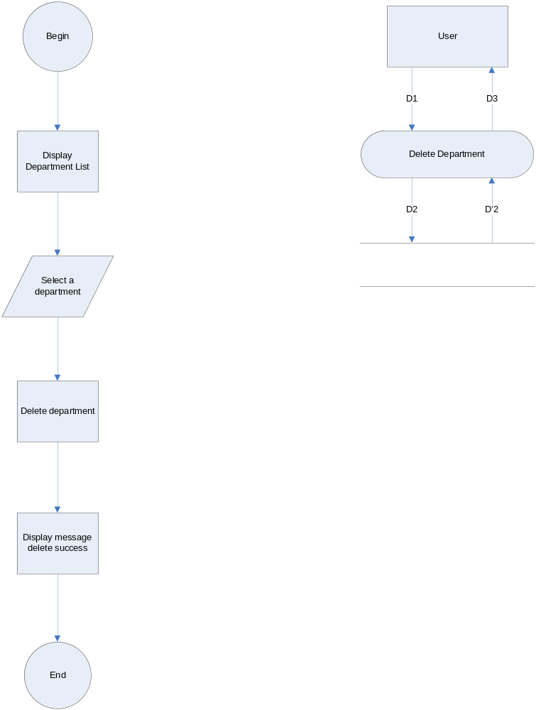
4.21.Search Departments
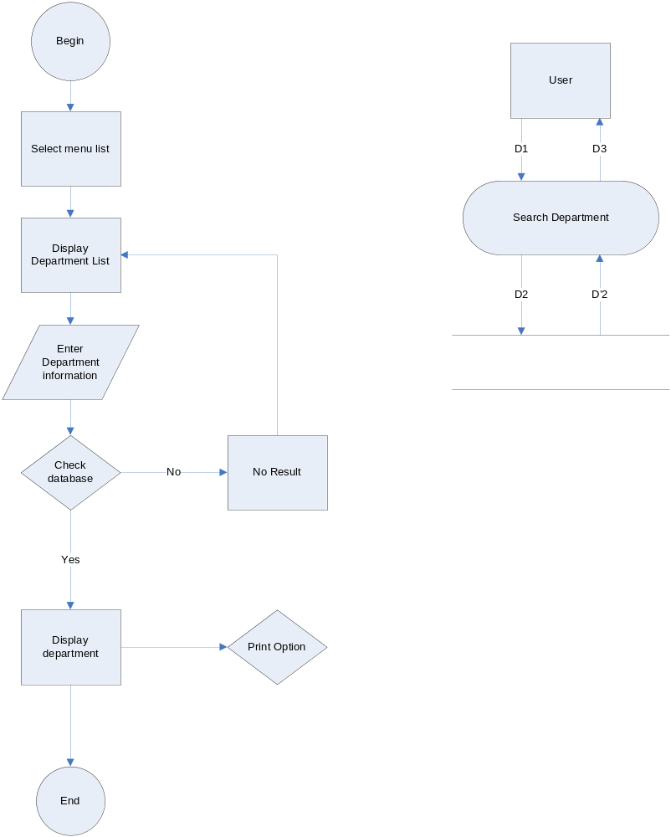
4.22.Rotate Employee
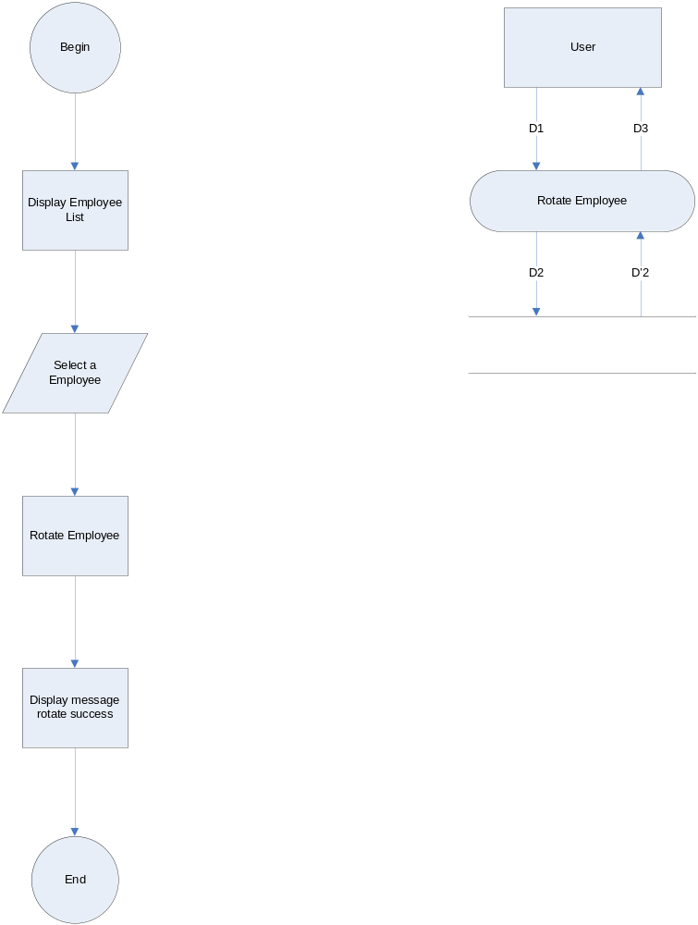
4.23.Process Vacancy

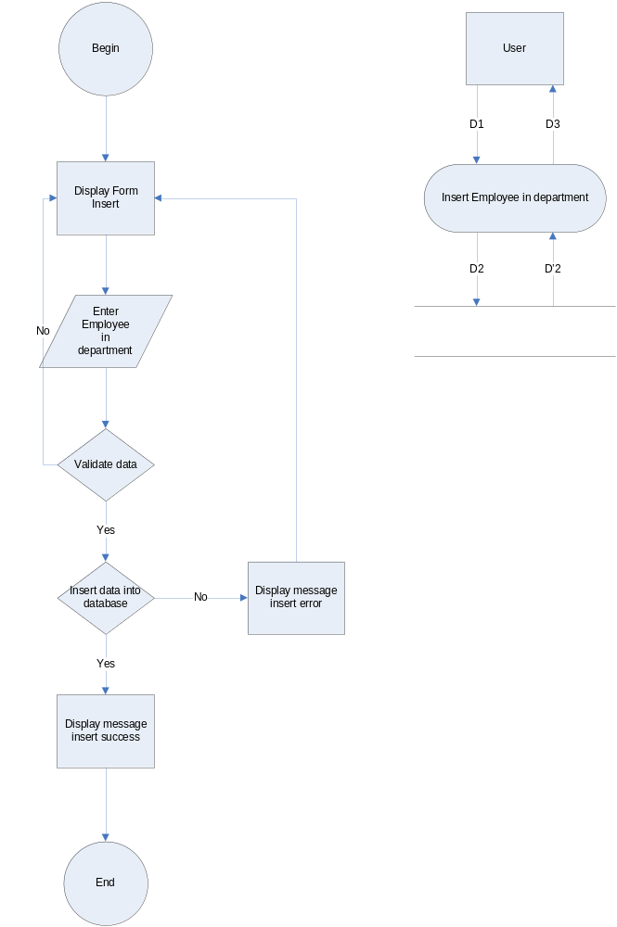

4.24.View Report
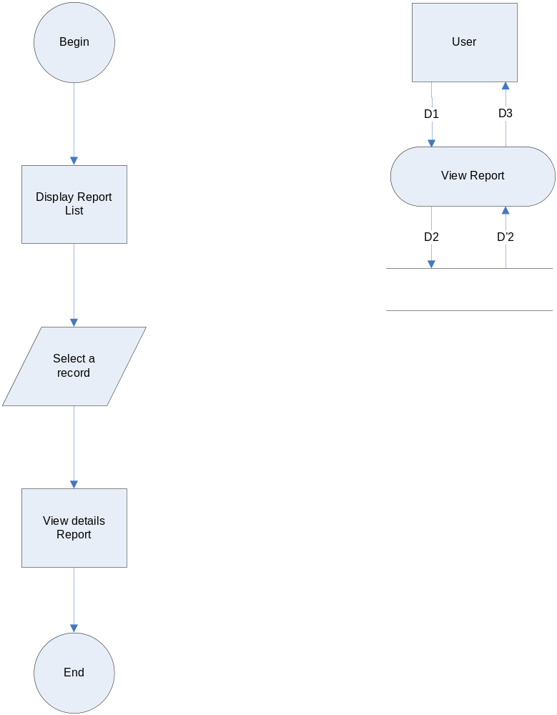
4.25.Add Vacancy
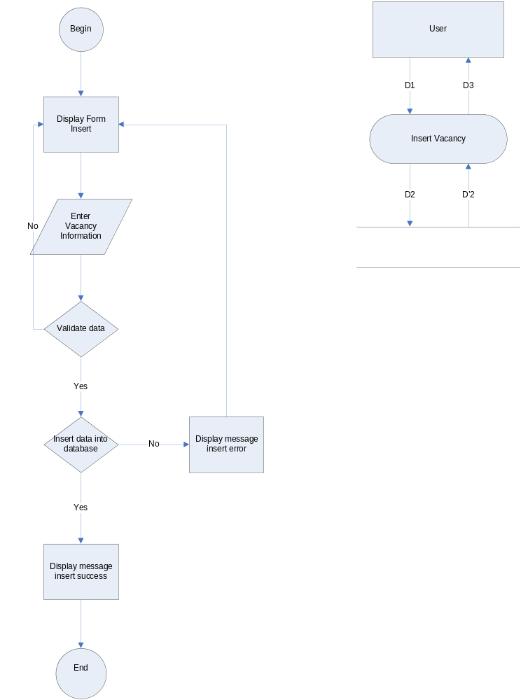
4.26.Update Vacancy
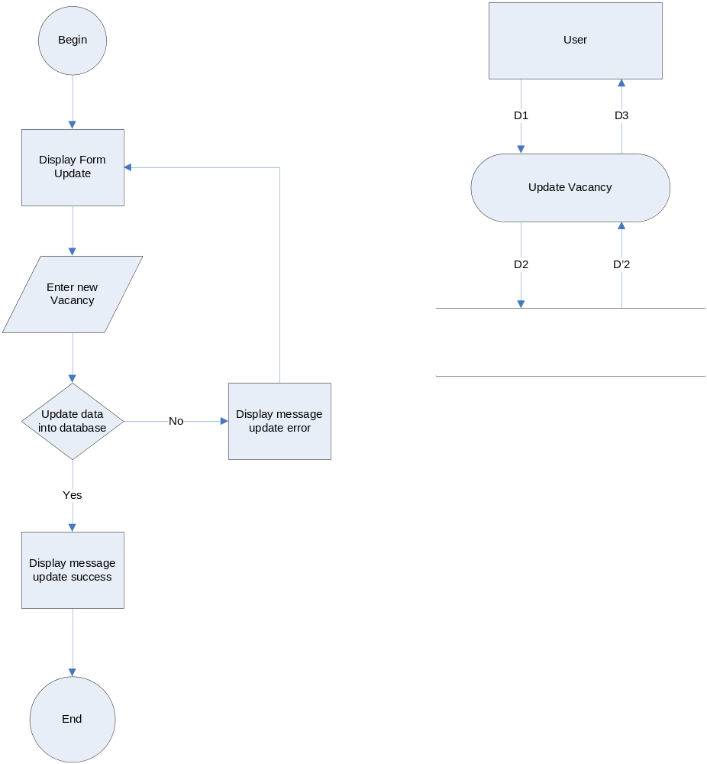
4.27.Delete Vacancy
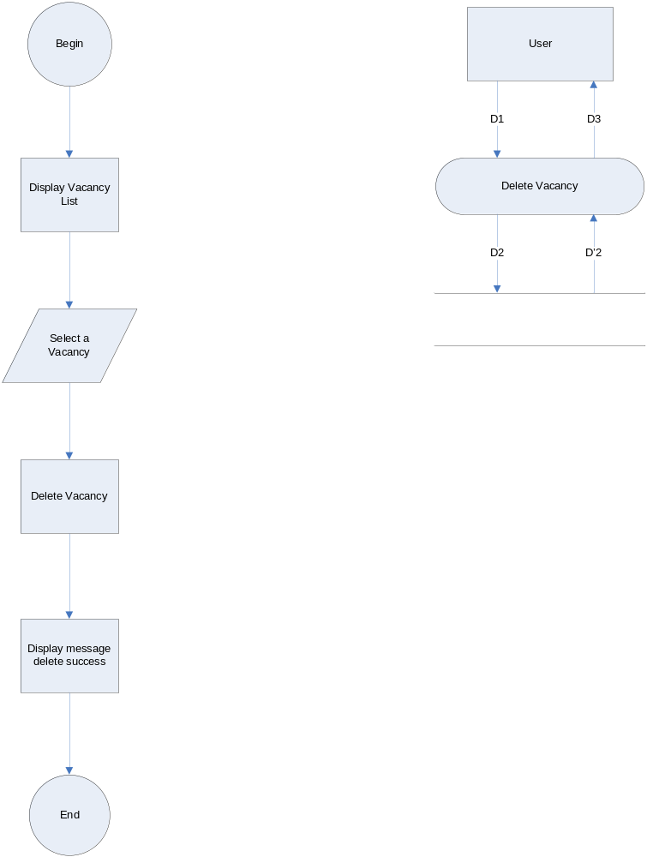
4.28.Search Vacancy
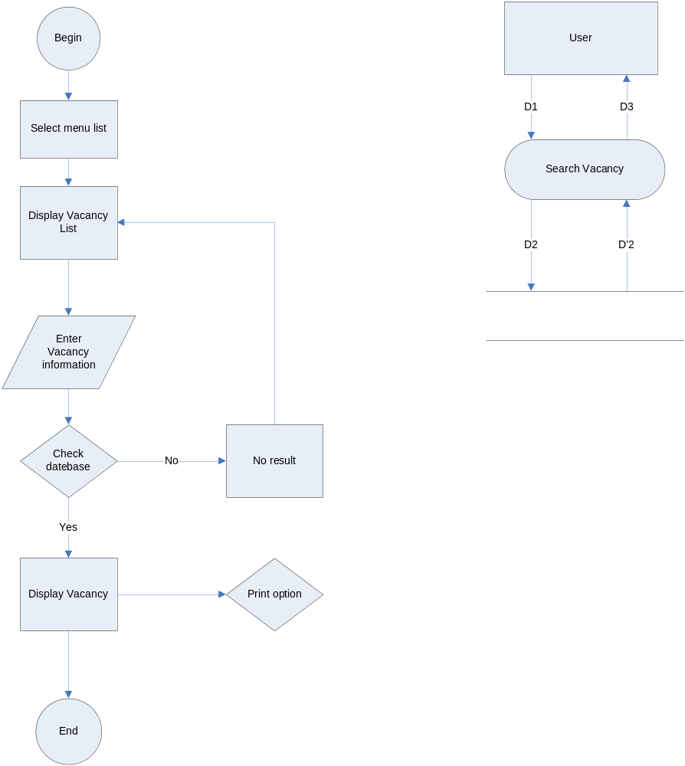
4.29.View Information
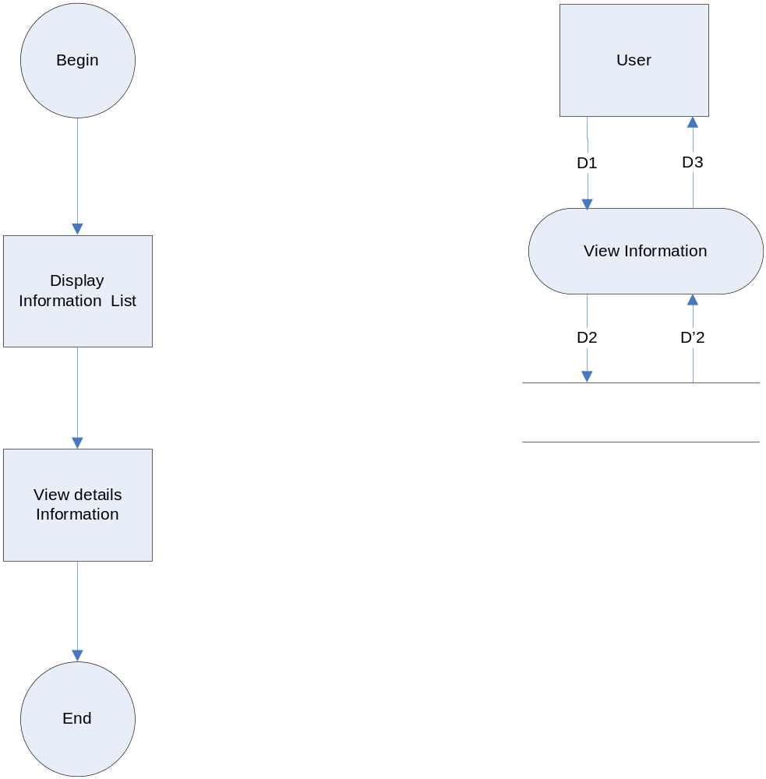
4.30.Update Information
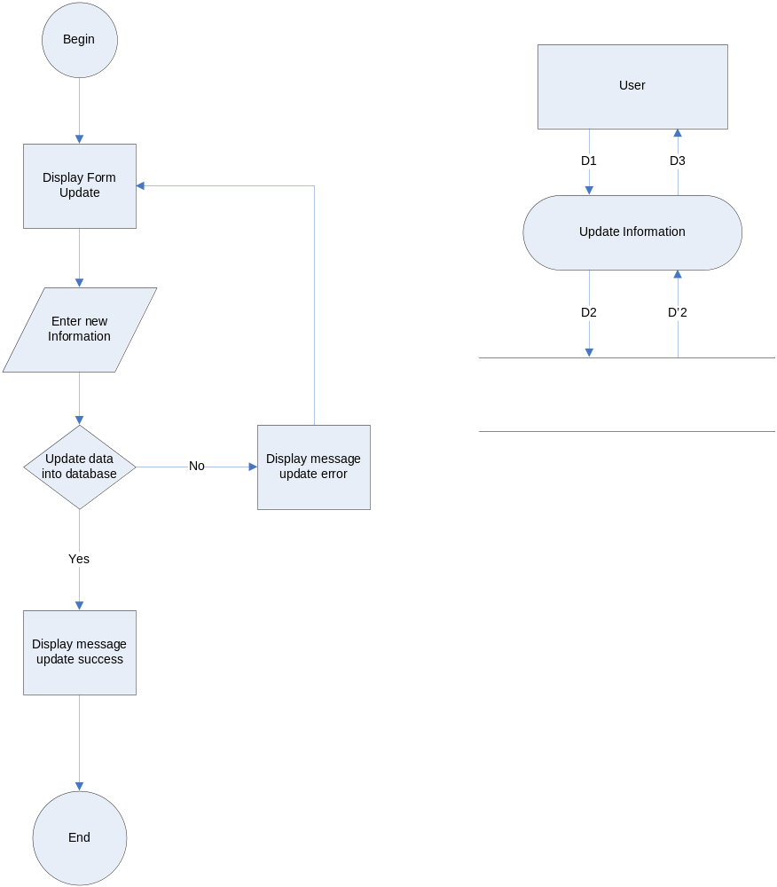
4.31.History Of Employees
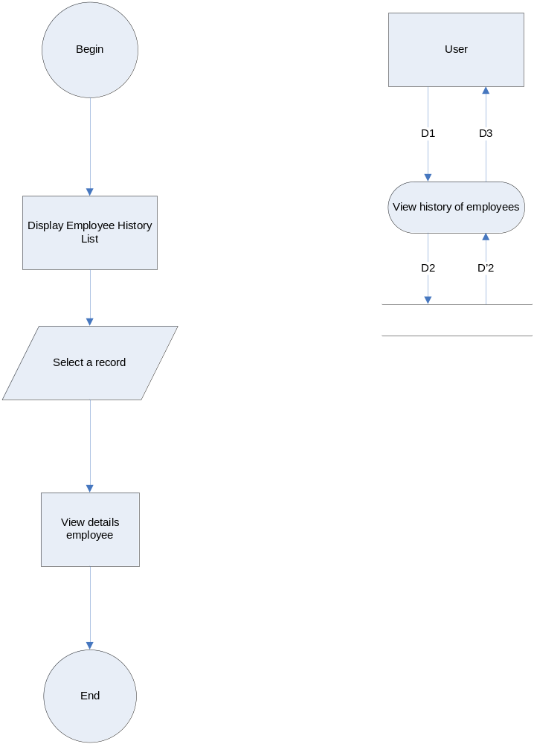
5.Database Design
5.1 Database Diagram
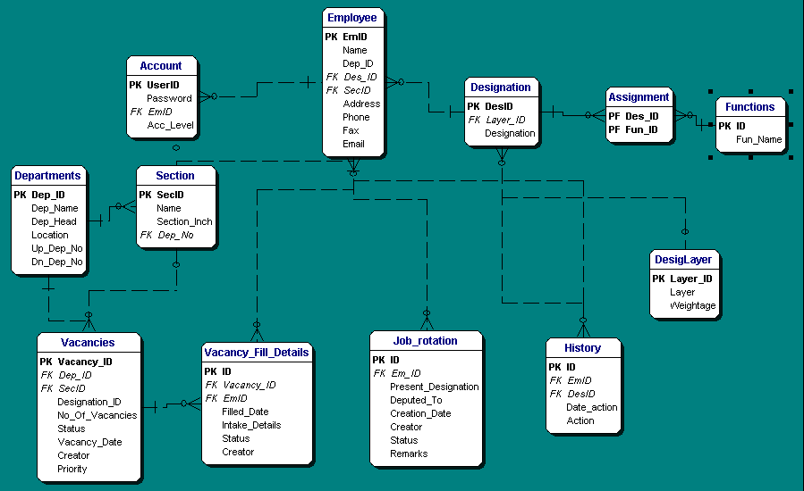
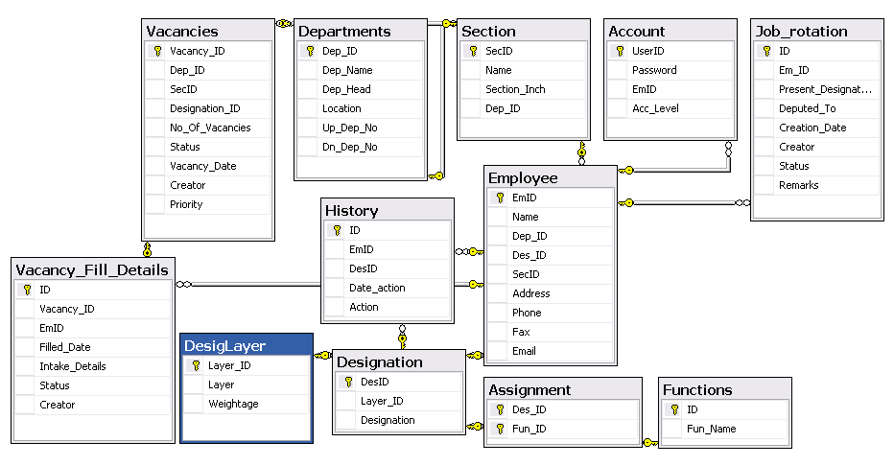
5.2 Desciption Table

Account Manager

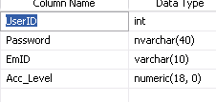
No | Fieldname | Description
1 | UserID | Number of Account (auto increment)
2 | Password | Password of Account
3 | EmID | Number of Employee
4 | Acc_Level | Level of account
Assignment
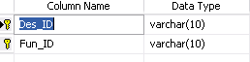
No | Fieldname | Description
1 | Des_ID | Number of denpendencies
2 | Fun_ID | Number of function
Departments
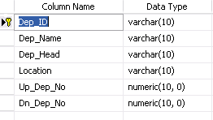
No | Fieldname | Description
1 | Dep_ID | Number of department
2 | Dep_Name | Name of department
3 | Dep_Head | Name of head department
4 | Location | Location of department
5 | Up_Dep_No | Number of Upper Department
6 | Dn_Dep_No | Number of lower department

DesignLayer
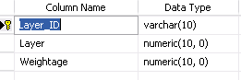
No | Fieldname | Desription
1 | Layer_ID | Number of Layer
2 | Layer | Layer
3 | Weightage | Weightage

Designation
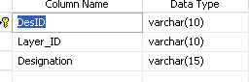
No | Fieldname | Description
1 | DesID | Number of designation
2 | Layer_ID | Number of layer
3 | Designation | Designation

Employee
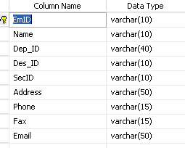
No | Fieldname | Description
1 | EmID | Number of employee
2 | Name | Name of employee
3 | Dep_ID | Number of department
4 | Des_ID | Number of designation
5 | SecID | Number of section
6 | Address | Address of employee
7 | Phone | Phone of employee
8 | Fax | Fax of employee
9 | Email | Email of employee

Function
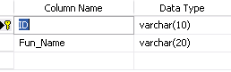
No | Fieldname | Description
1 | ID | Number of function
2 | Fun_Name | Name of function

History
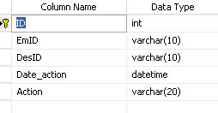
No | Fieldname | Description
1 | ID | Number of history
2 | EmID | Number of employee
3 | DesID | Number of Designation
4 | Date_action | Date of action histor
5 | Action | Action

Job Rotation
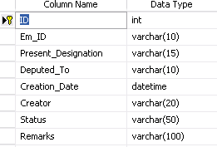
No | Fieldname | Description
1 | ID | Number of job rotation
2 | Em_ID | Number of employee
3 | Present_Designation | Present designation
4 | Deputed_To | Deputed to
5 | Creation_Date | Date of creation
6 | Creator | Creator of job rotation
7 | Status | Status of Job rotation
8 | Remarks | Remarks of job rotation

Section
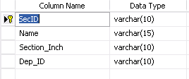
No | Fieldname | Description
1 | SecID | Number of section
2 | Name | Name of section
3 | Section_Inch | Section inch
4 | Dep_ID | Number of department

Vacancies
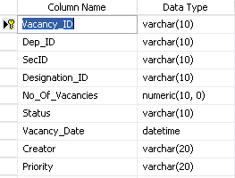
No | Fieldname | Description
1 | Vacancy_ID | Number of vacancy
2 | Dep_ID | Number of department
3 | Sec_ID | Number of section
4 | Designation_ID | Number of designation
5 | No_Of_Vacancies | Numbert of vacancies
6 | Status | Status
7 | Vacancy_Date | Date of vacancy
8 | Creator | Vacancy creator
9 | Priority | Priority

Vacancy Fill Details
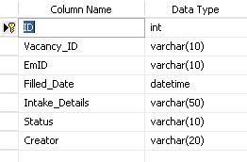
No | Fieldname | Description
1 | ID | Number of vancancy fill details
2 | Vacancy_ID | Number of vacancy
3 | EmID | Number of employee
4 | Filled_Date | Fill date
5 | Intake_Details | Intake details
6 | Status | Status
7 | Creator | Vacancy filling details creator

6.Site map
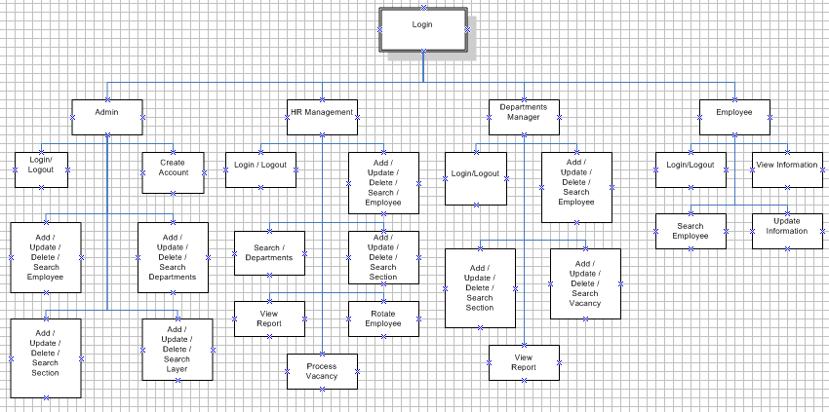

7.Interface System
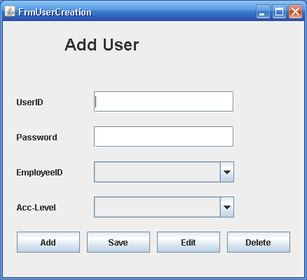
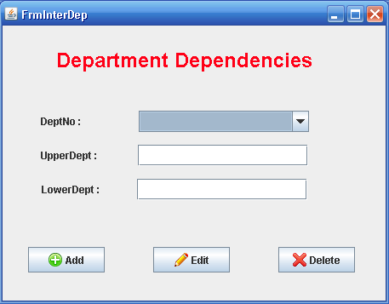

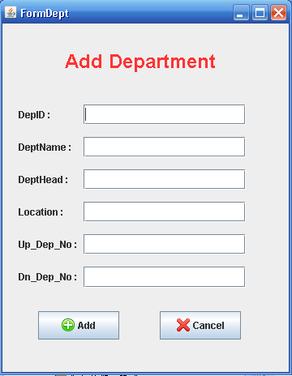

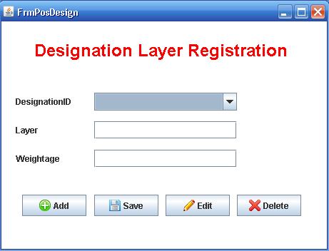

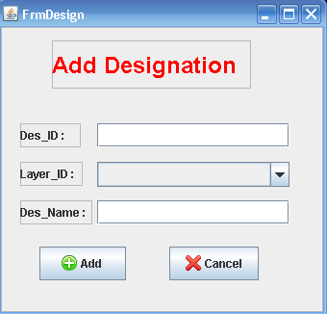

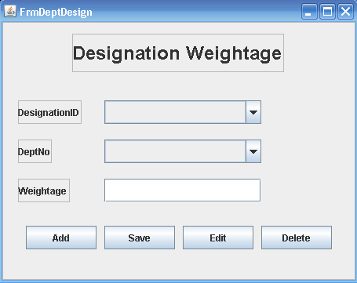

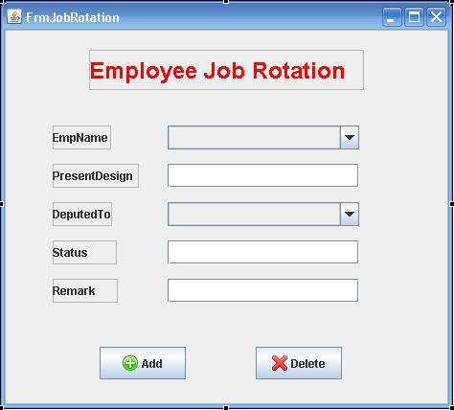

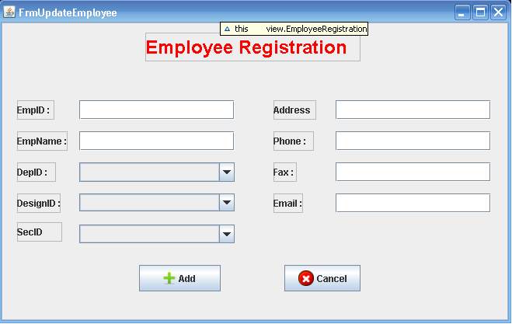

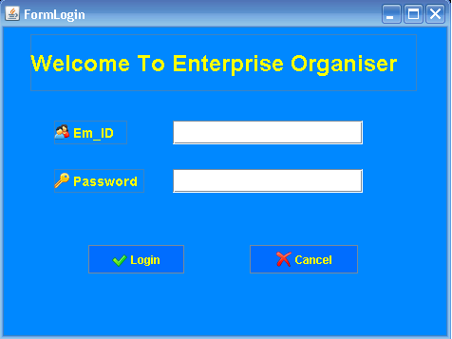

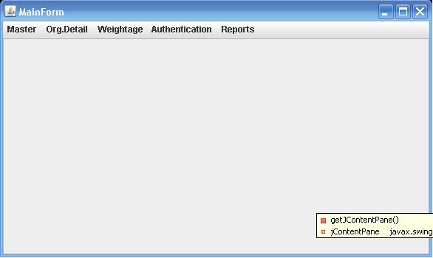

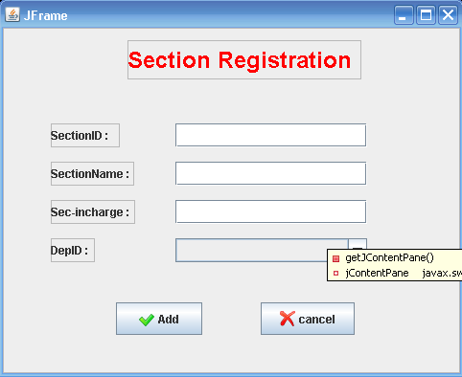

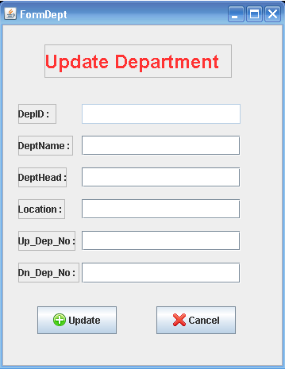

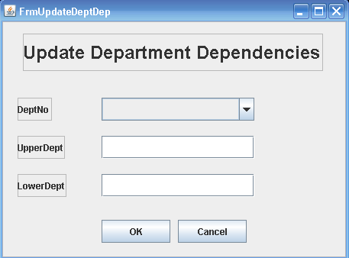

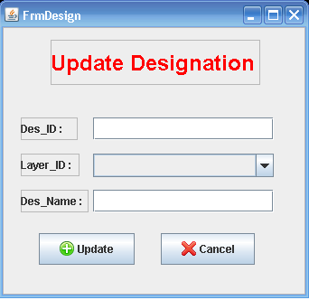

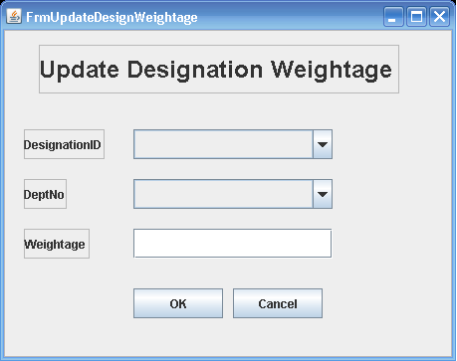

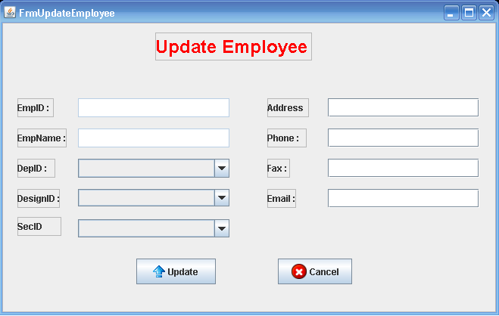

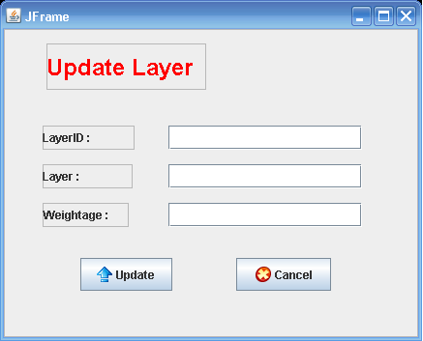

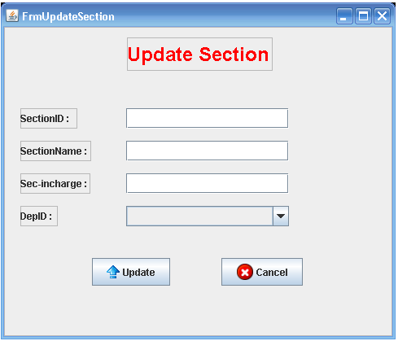

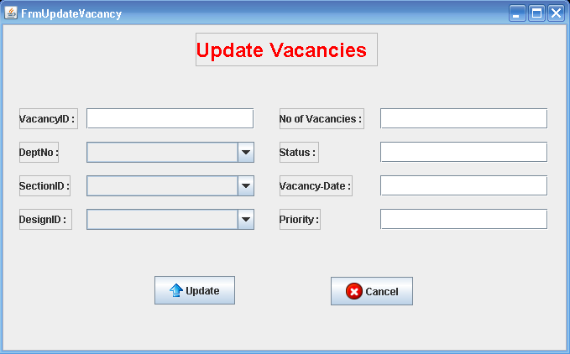

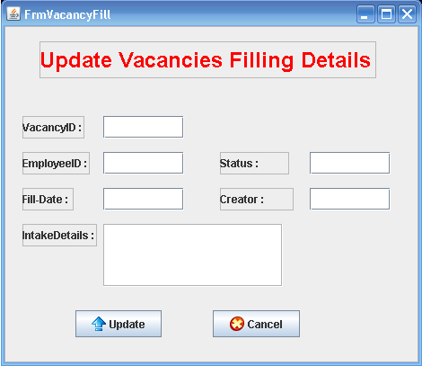

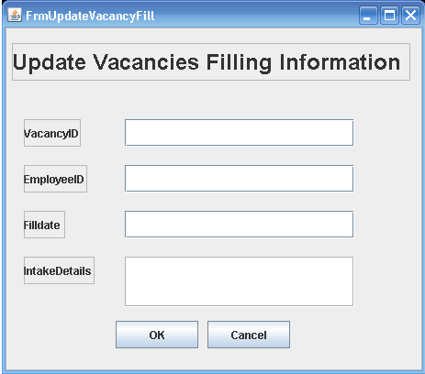

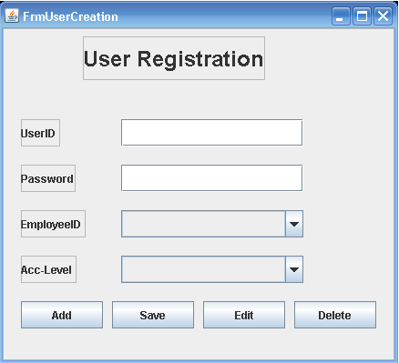

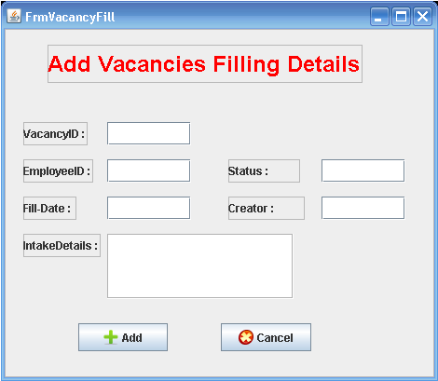

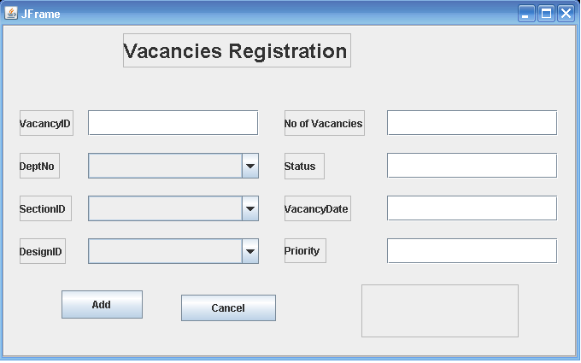

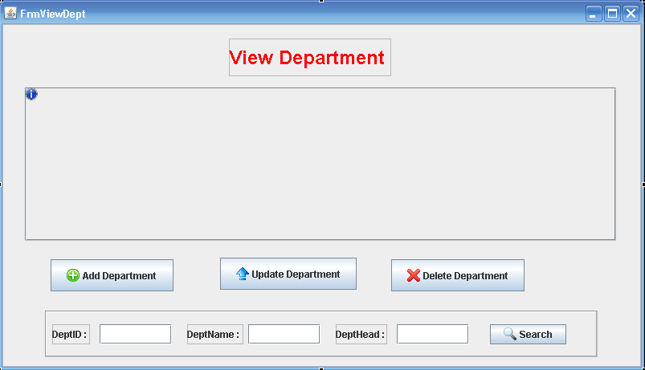

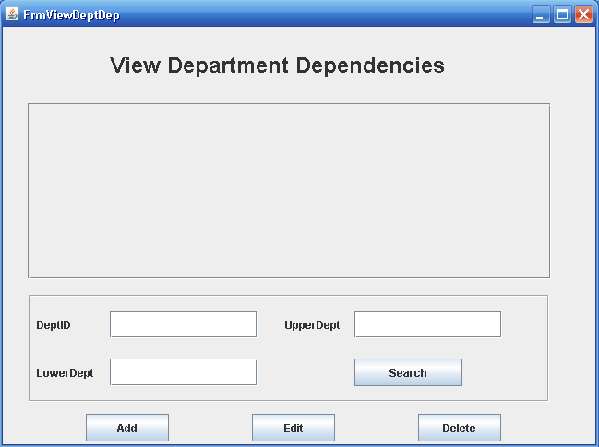

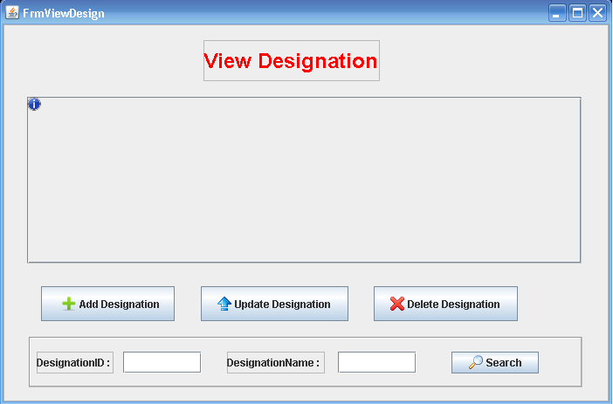

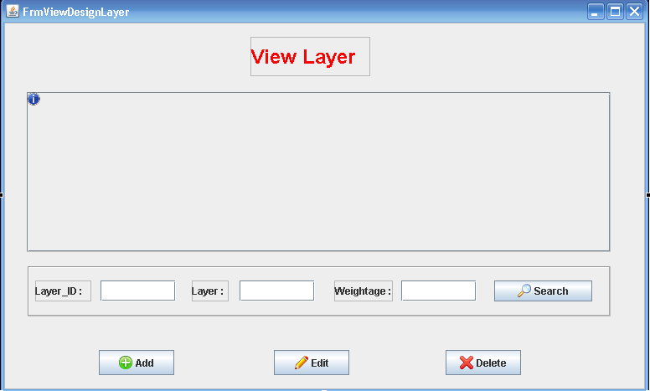

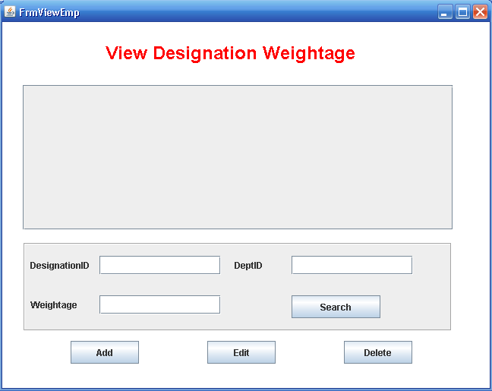

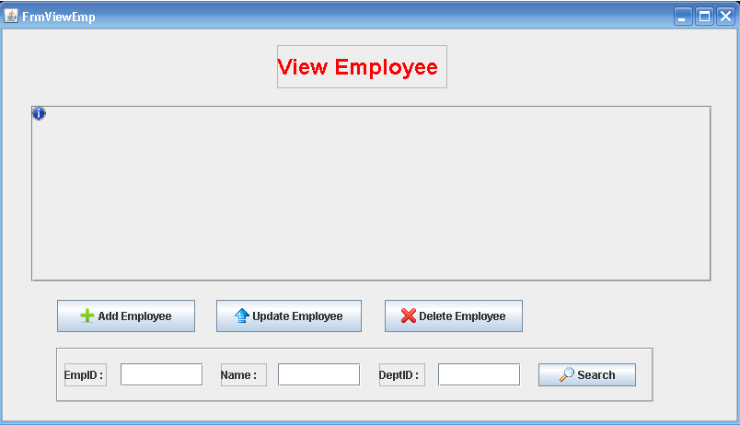

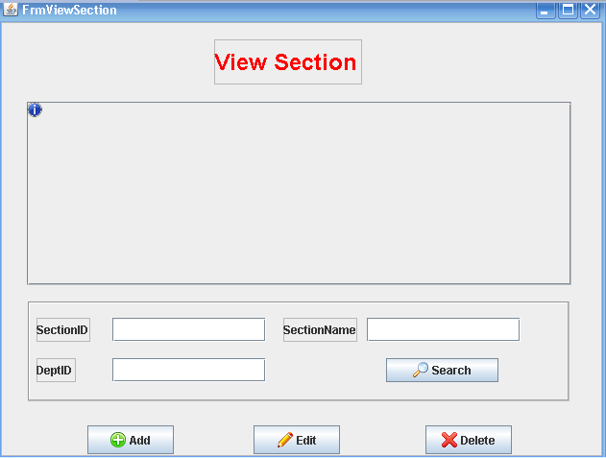

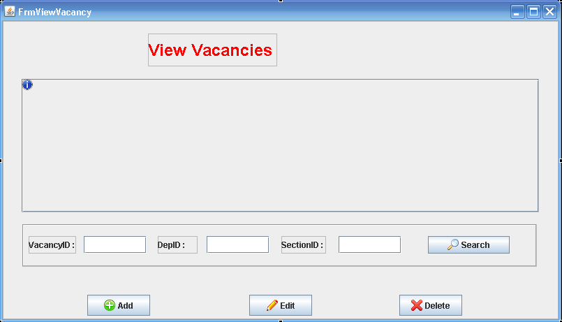

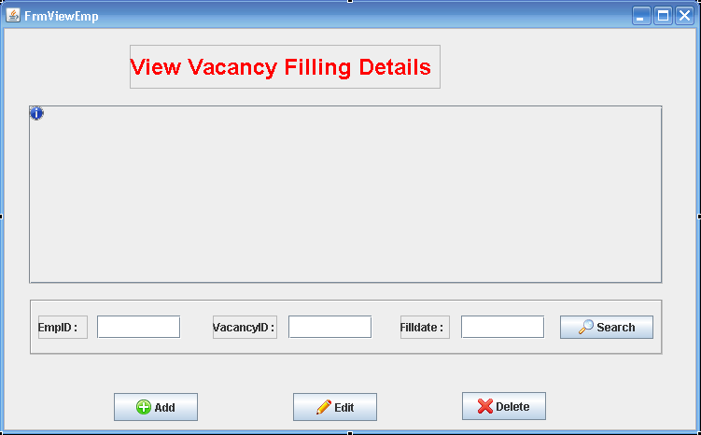
8. Task Sheet

